Bengal kitten care package

# What is a bengal cat?

**A Bengal cat is a little wonder of nature! He is a hybrid cat, a cross between the domestic cat and the Asian leopard (Prionailurus Bengalensis), a small wild cat found in Asia and more particularly in the Bengal region. The result of this fusion is spectacular: a mini leopard with the “Wild” look of the Asian leopard and the “Sweet” temperament of the domestic cat!**

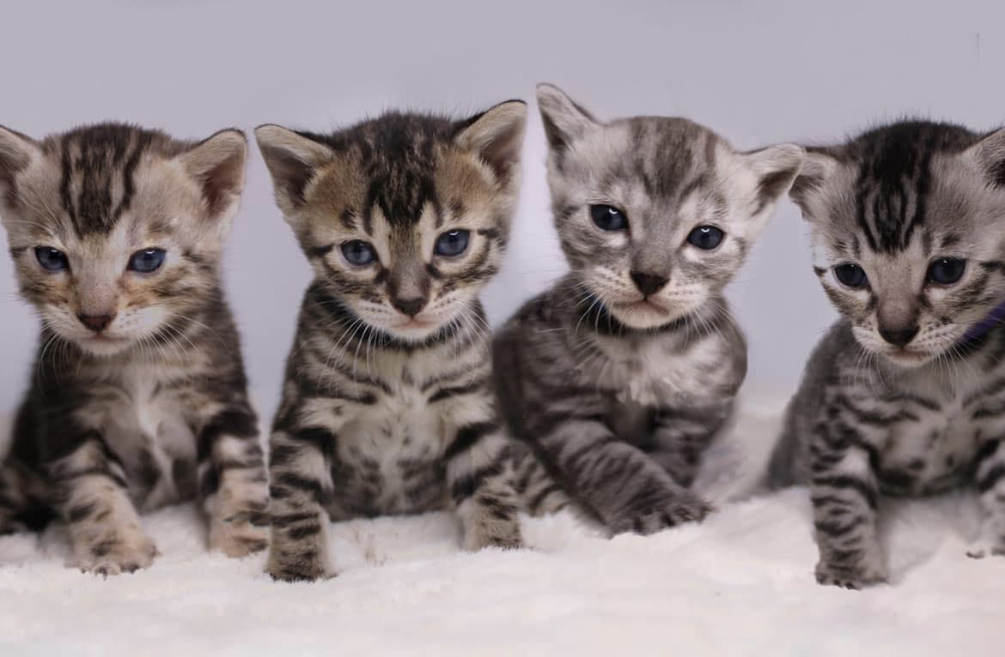

***FuzzinG stage in bengal kittens***

Fuzzing (fuzzy – “frizzy", “indistinct") is a feature inherited by Bengal cats from wild ancestors - ALC or in another way Asian Leopard Cats. Surely, little leopards, beginning to perceive the world around, needed protection to survive in the jungle. And what can protect them if not a “disguising” coloring?

*Fuzzing is a process that almost all Bengal kittens at the age from 1 to 4 months go through. Bengal kitten is finally cleared of fuzzing by about 8 months. And sometimes this change completely ends by 1.5 years. The kittens are covered with grayish or whitish pale strands of fur sticking out in different directions. If the fuzzing is not very strong, then the kitten's pattern looks slightly shaded and indistinct. In the case of strong fuzzing, it is almost impossible to see the pattern on the fur coat.*

***Before bringing your new bengal kitten home:***

Here’s a list of things you'll need before you take your new baby home.

Below you'll find many items that you can get for your kitten from Amazon, Walmart, Target, Chewy, etc.

* **Litter box** (make sure the box is roomy to prevent scattering litter around the house)
* **Litter scoop**
* **Litter substrate** (initially start with the litter the cat is currently used to)
* **Food and water bowls** (your kitten may have a lot of energy so finding bowls that aren’t easy to tip over are good. You’ll want to wash their bowls daily to keep things fresh. Plenty of clean fresh water on hand is key for a healthy kitten.
* **Water fountain** (optional) bengals very much love to have fresh water.
* **Food** (we are currently feeding our bengals science diet – Hills – sensitive digestive
* Bed (Most kittens like to have their own place to rest, but don’t feel disappointed if they choose to ignore their own bed. Until you see what your kittens preferences are, you don’t have to spent a lot of money on a fancy new bed. Even a cardboard box with a plush blanket will do! )
* **Scratching post** (it’s a popular belief that cats use their scratching post to sharpen their claws. They use it for exercise , stretching, cleaning away dead scales from their nails , to mark their territory visually/ w scent and to dull down their claws. The scratching post should be sturdy and tall enough to let your kitten stretch out full length. The higher the tree the better ! It may actually keep the bengal off your higher furniture pieces.encourage them to use the scratching post by playing with them near it often.you can also use catnip on the scratching post to get them interested in it.
* **Collar/harness/leash** (a cat harness or leash can be a great training tool for your kitten, though it’s not a must. If you’re already thinking along these lines, a harness is probably the best, as kittens often dislike the feeling of a leash. However, make sure your kitten wears a collar madras lightweight as possible with and ID tag if you are to use one.
* **Grooming tools** (bengals don’t need to be brushed too often and if you’re going to cut their nails use nail trimmers for cats not human nail trimmers.)
* **Toys** ( a kitten is naturally curious and needs toys that are safe and fun to play with.choose toys made especially for cats – ones that cannot be splintered, torn apart or swallowed. A celluloid ball that rattles , a catnip mouse or a hard rubber mouse is perfect. To avoid accidents, some cat toys should be used only when you’re playing with your kitten.

***Introducing the kitten to your home***

1. We will provide you with a Kitten Starter Pack containing enough food *for the first 2 days.* You are welcome to contact us for any tips on nutrition.

2. Have a clean litter box ready. Our kittens are litter trained and are used to Grass seeds or silica crystals by the brand So Presh .

When you bring your new cat or kitten home show your kitten immediately where his/her litter box. If you have more them one cat or live in a big house with multiple floors, please consider putting a box on each floor.

A clean litter box is key because your kitten will avoid using a messy, smelly one. Wash her pan once a week with soap and water. It is best not to use strong disinfectants (containing ammonia); they aren’t necessary and may offend your kitten’s sensitive nose. Use a mild disinfectant such as bleach and water on the litter box about once a month, putting the box outdoors to dry in the fresh air, if possible. Always wash your hands thoroughly after handling.

3. Have suitable bowls for food and water ready.

You'll want to wash her food and water bowls daily to keep things fresh. Plenty of clean, fresh water on hand is key for a cat/kitten too.

4. *VERY IMPORTANT!!* Set aside a quiet and preferably small room (if possible with a soft bed or couch) for your cat/kitten. You must let your new pet stay in this room until he/she becomes comfortable with you and is eating well.

This helps the new cat/kitten to calmly explore the new place, as well as get used to you. It is important to give time, and to talk sweetly and act very gently towards your new pet. If he/she wants to stay hidden, leave him/her doing that, don't force him/her out or you might either get scratched or scare the kitten.

After the cat/kitten starts to be more comfortable with you and he/she is eating well, you can let the door open in order for him/her to start exploring the new environment.

If the cat/kitten is crying after you leave the room and runs towards you when you are entering that room, he/she is definitely ready to explore the new home.

5. If you have other pets, either cats and dogs, do not let them with your new cat/kitten immediately, as this could get the animals hurt as well as compromise your relationship with your new pet.

While the cat/kitten is settling in the new room, let your other pets sniff around the door and on you to get used to the smell of your new pet. Do not force the animals together, but introduce them slowly and monitor them. For the first period, do not leave your new cat/kitten alone with your other pets, especially if you are outside the house. Accidents can and will happen. You can leave them together after you are 100% sure that they will get along.

6. When you are entering the room, place the carrier on the floor and let your cat/kitten come out on his/her own. Be calm, quiet and relaxed. You can use a feather teaser-toy to encourage your new pet to come out of the carrier.

7. Make sure that your new cat/kitten knows exactly where the litter tray and food is. After exploring part of the house, at the beginning, he/she might get lost so you will have to help him/her to find the litter tray and food.

8. Sit or lie on the floor at your kitten's level to play and socialize. Do not do quick movements or he/she might get scared.

9. You might have to place your new pet several times in the litter after arrival. Make sure he/she is using it.

10. Check that your cat/kitten is eating and drinking regularly after the first few days.

11. Do not introduce too many people at once to your kitten/cat. Make sure he/she is first getting comfortable with you and then slowly introduce new family members.

12. Do not let your kitten/cat run the full house immediately. Also, do not let him/her outside (even on a harness) until the cat/kitten is comfortable with you.

13. Make sure to remove any possible hazard in order to avoid accidents with your new cat/kitten. Remove also small objects or anything that the cat might get and play with. Remember, it is never the cat/kitten's fault, it is yours!

14. Bengal cats and kittens are very smart and active, soy make sure to provide them with different toys and ample space to play. They must feel stimulated and not bored.

If you follow these simple rules introducing the new cat/kitten to your home will go smoothly and will be a good experience for you.

***Vaccines***

When you pick up your Bengal kitten it will have already received the first round of core vaccinations and deworming medication. Kittens are correctly vaccinated at 8 weeks and at 12 weeks of age. The first series of shots a kitten will get is a DRCC/FVRCP vaccination against Feline Distemper (Panleukopenia), Rhinotracheitis, and Calici virus. These vaccines help protect against upper respiratory diseases, herpes and fatal viruses. Annual revaccination with a single dose is recommended.

Keep in mind that Rabies vaccine cannot be administered until 16 weeks of age and is the new owner's responsibility. Kittens also need to be with their mothers and litter mates for a minimum of 10- 12 weeks for proper health and social development. Kittens should never be permitted to leave a Cattery prior to 10 - 12 weeks of age. If a Cattery is selling at earlier ages, such as 6,7,8, even 9weeks of age, they are not properly vaccinating or giving the Kittens their best chance at a happy, healthy, long life. At Indigo Exotics Bengals Cattery, we vaccinate at 8 – 10 weeks of age. If a Cattery does not follow these recommendations and guide lines, so they cannot guarantee the health of the kitten.

**What Vaccines Do:**

A vaccination is a small virus which is injected into a kitten to help build a response that builds the kitten's immunity against a particular disease. The virus injected has been modified so the kitten will not get sick from the introduced virus, but is effective in building a resistance.  
A vaccination should help create antibodies that help a kitten fight disease and protect him as long as the antibodies are in the cat's system.

**RABIES VACCINATION:**

Keep in mind that Rabies vaccine cannot be administered until 16 weeks of age and is the new owner's responsibility. .

So, what is rabies? Well, rabies is a virus that is called a bullet-shaped Rhabdovirus that can enter the body by saliva of an animal that is rabid. Usually this is transmitted to another animal by biting. After the virus has entered the body it will travel to the central nervous system via the spinal cord and then finally attacks the brain of the victim. The main reason why rabies is so much dreaded and deadly is because once it gets into the central nervous system, the immune system simply cannot respond to this attack from the invading virus and death is unavoidable. Something you surely don’t want to see happen to your [Bengal kitten.](https://www.royalbengalcattery.com/kittens/available-kittens.html)

Right now there currently are 27 states along with the District of Columbia that requires that your Bengal kitten and all cats receive rabies vaccinations. Even if your Bengal kitten is going to be kept indoors. The vaccine will help protect your kitten from people and other animals they might come in contact with, so it’s vital that your kitten receives their rabies vaccination. Not only will it protect your kitten but should you not have proof that your kitten is vaccinated and they scratch someone, you may be at a high risk of having your Bengal cat taken away from you and euthanized in some states! So, it’s really not worth the risk.

VACCINES KITTENS DO NOT NEED:

If a kitten will be an indoor only pet, a Fiv/Felv (feline leukaemia and feline immunodeficiency virus) vaccine is usually not necessary. However, FEL vaccine can cause sarcomas from the killed viruses in the vaccine. The FIV's efficacy is questionable and can cause tests to show a false positive.

.   
The Chlamydia vaccine is not recommended for cats at little to no risk of contracting the disease. This vaccine has a high rate of cat illness symptoms and should only be used based upon the prevalence of the condition and the breeding conditions.

FIP (Feline Infectious Peritonitis) is a viral disease that is almost always fatal. The intranasal vaccine that has been created has not proven effective in preventing feline FIP. Vaccines are only recommended for high-risk cats.

Other immunizations kittens don't need include the dermatophytosis (ringworm) vaccine, yellow fever immunization, the Bordetella vaccine, and the giardia vaccine; they are not recommended by most veterinarians. Many of the vaccines that are unnecessary have serious side effects or are ineffective and cannot be treated with cat meds.

The American Veterinary Medical Association and the American Association of Feline Practitioners advise that kittens with lower risks of disease exposure may not need booster shots on an annual basis for most illnesses. However, recommendations vary by breed, potential of exposure, the health of a cat, and the geographic location in which the kitten lives. Talk with your veterinarian to determine which vaccinations are most appropriate for your kitten.

***Spaying/Neutering (sterilization)***

You are required to have your kitten sterilized by 6 months the latest and have the vet paperwork of the procedure mailed to me for my records to comply with You do not want your kitten anywhere near sexual maturation and some cats can mature before 6 months. Imagine what you were like all hormonally-charged during your puberty, and then imagine your kitten going through that! Most behavior problems are sexually driven!  
There are numerous reasons you should spay or neuter your cat! Let’s talk about health reasons first…

Female cats that are spayed CAN’T get uterine cancers; their risk of mammary (breast) cancer is reduced by 25%; and they are less prone to urinary tract infections and hormonal changes.

HMale cats that are neutered CAN’T get testicular cancer, and they live 40% longer than their unneutered counterparts.1 Unneutered male cats respond to the “call of the wild” and their desire to wander is fierce. Unneutered male cats may become aggressive toward other cats, increasing their risk of injury and becoming infected with feline leukemia and/or feline immunodeficiency virus. And don’t forget: unneutered male cats tend to spray urine, which STINKS!

***ANESTHESIA SUBSTITUTION***

*ALSO VERY IMPORTANT TO TALK TO YOUR VET ABOUT ANESTHESIA SUBSITUTIONS FOR YOUR BENGAL. Ketamine and Tieltamine can Be very harmful to the bengal breed and can deteriorate Your cat.*